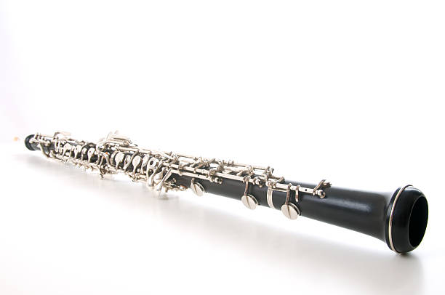

**Spellings**

Spellings will be set every Friday on Tapestry and displayed in the class window. Your child will have a sticker on to let you know which spellings they will be practicing. Please ask if unsure. Children will be tested on a Friday.

**Rainbow Challenge**

The children will be taking part in Rainbow challenge time three times a week in the afternoon. They complete 5 challenges linked to their learning in maths, literacy, topic, art and building fine motor skills.

This week, the children have matched capital letters, enjoyed cutting out a shopping list from Aldi’s magazine and sorted through different objects for maths.

**Read Write Inc (RWI)**

We will be starting RWI lessons this term which will run every day. This will support the children with their reading and writing immensely.

We will soon be sending reading books home matched to your child’s reading level. Please could you listen to your child read throughout the week to support children’s progression and confidence. Reading books are changed every Friday and staff will ask for reading books to be handed in at the door.

**Maths**

In maths this term,

children will be developing their knowledge and understanding within place value.

The children will be counting to 10 or more, sorting different amounts, representing groups in different ways and looking at addition and subtraction.

Maths homework will be given every Friday linked to their learning in class. Please could this be returned by the following Friday.

Here is a useful online game that can support further learning at home, <https://www.topmarks.co.uk/maths-games/5-7-years/counting>

**P.E and Forest School**

P.E is on a Monday and Tuesday. Please could children wear their P.E kit into school on this day. The P.E kit includes normal school jumper, t shirt, jogging bottoms or leggings and trainers. Forest school will be on a Thursday. Please could children have a coat and named wellies in school on this day.

**Hello!**

Welcome to our newsletter for **Term 1.** We hope everybodyhad a lovely summer break. We have lots of exciting activities planned for this term and look forward to getting to know the children. Our class activities will link to our class topic ‘**This is me**’.

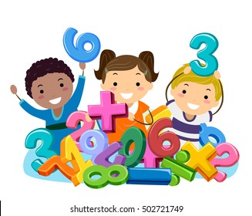

**Literacy**

This term in literacy, we will be exploring the use of capital letters, full stops, writing on the line and finger spaces. The children have already been exploring capital letters by practicing writing them, matching them to lower case letters and writing our names.

**History**

In history this term, children will be looking at past and present events.

We will be thinking back to our own memories and also making comparisons between our own lives and the lives of our parents and grandparents.



