French Horns and Flugel Horns
LITERACY
In Literacy this term we will be reading the book “Blue John.” We will be looking at characters feelings, layouts of letters and how to write one.
Throughout Year 4 grammar and spelling are focussed on and this term we are looking at fronted adverbials, conjunctions, prepositions, the use of paragraphs as well as homophones.
We will be doing regular short writing to improve handwriting and word choices, as well as whole class guided reading and how to tackle reading comprehensions.
We will also be exploring the poem ‘I am the seed that grew the tree’. We will be exploring Haikus based on the natural world and we will link these with others in the group to make a series, known as Renga.

MANY THANKS FOR YOUR CONTINING SUPPORT WITH HEARING YOUR CHILD READ AT HOME. IT CAN HAVE SUCH A POSITIVE EFFECT ON CHILDREN’S PROGRESS.

NUMERACY
This term, in year four, we will be focussing on money and time. Reading time (in particular analogue clocks) is a very complicated concept for the children to learn. We will, of course, be covering it thoroughly at school but if there are any opportunities to practice this at home that would be very beneficial to the children. Towards the end of term, we will investigate shapes and their properties and also do some work on position and direction.

TOPIC
PSHE – In PSHE this term we will be exploring our understanding of the law and why we have it. We will be looking in how to be resourceful and this can support problem solving. We will also be deepening our understanding of how our failures can drive success and what qualities are needed to be a good leader.
Computing – This term in computing we are going to be collecting and organising data in different ways
RE – Our focus this term is on Christianity. We will be looking at why it important for Christians to go to church. Our enquiry question -Do people need to go to church to show they are Christians?
Geography – We are going to be exploring and comparing polar regions and the position and significance of time zones. We will be identifying the key features of human and physical features of Antarctica and we will learn how to use a four-figure grid to plot out expeditions to Antarctica.
Art – We will be looking at patterns all around us and we will be making different patterns using colours and natural materials.
D.T –In DT this term we will be exploring food. We will design, make and evaluate our own bread.
History – Our focus this term is Ancient Greece. We will be exploring what life was like in Athens and Sparta. We will explore city-states and how they overcame the Persian invasion. We will also explore the leaders King Philip II and Alexander the Great.
MANY THANKS FOR YOUR CONTINUING SUPPORT WITH HEARING YOUR CHILD READ AT HOME.
20 MINUTES A DAY CAN HAVE SUCH A POSITIVE EFFECT ON YOUR CHILD’S PROGRESS.
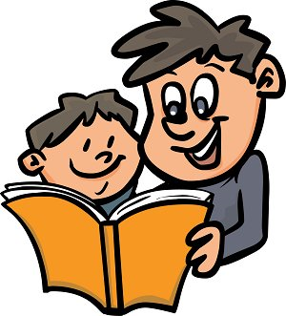
Please remember to write a comment and include an adult initialled signature.

PE will be on Tuesdays and Fridays. Please ensure students are dressed appropriately for outdoor weather.

Welcome to
Year 4 Term 6
Science – In Science this term we are exploring how sound is created. We will be identifying the patterns of sound and how sound gets fainter as the distance from the sound source increases.

Art

