French Horns and Flugel Horns
LITERACY
In Literacy this term we will be reading the book “Escape from Pompeii”. We will be looking closely at characters’ feelings and overcoming fears.
We will also be exploring the Literacy shed Film ‘Contre Temps’. We will be using this medium to explore Narrative writing and dialogue.
Throughout Year 4 grammar and spelling are focussed on and this term we are looking at noun phrases, conjunctions, paragraphs and the use of direct speech.
We will be doing regular short writing to improve handwriting and word choices, daily spelling, as well as whole class guided reading and how to tackle reading comprehensions.

MANY THANKS FOR YOUR CONTINING SUPPORT WITH HEARING YOUR CHILD READ AT HOME. IT CAN HAVE SUCH A POSITIVE EFFECT ON CHILDREN’S PROGRESS.

NUMERACY
This term we will be completing our work on multiplication and division. We will learn how to multiply numbers using written methods. We will be learning to calculate lengths and perimeters and also look at fractions and decimals.
We will continue with our work on times tables and our new tables this year are 7, 9, 11 & 12. Please practise times tables as often as possible as really speedy recall is really important for all areas of maths.

TOPIC
This term our school value is tolerance. We will be promoting the culture and peace of others well-being and diversity.
PSHE – In PSHE this term we are looking at what to do when we or others don’t feel okay, how we can make changes through our choices, identity and gender and how to use apps safely.
I.C.T – This term I.C.T will focus on technology in our lives. The students will learn how to create a hyperlink and how to check who owns pictures online.
RE – In RE this term we will be exploring Judaism and how they live their life and how they show their respect for God.
History– In History this term we will be looking at the Romans. We will be exploring what Roman life was really like, why they invaded Britain and what influence they have had on the modern society.
Art – In Art this term we are keeping to the Roman theme by creating Roman Mosaics and Roman jars.

MANY THANKS FOR YOUR CONTINUING SUPPORT WITH HEARING YOUR CHILD READ AT HOME. 20 MINUTES A DAY CAN HAVE SUCH A POSITIVE EFFECT ON YOUR CHILD’S PROGRESS.
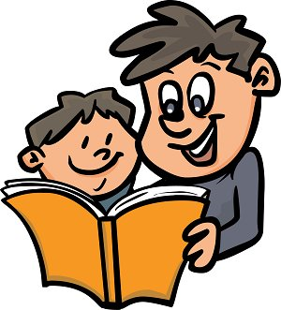
Please remember to write a comment and include an adult initialled signature.
Homework will be on Edshed and TTRockstars on a Friday and due in by Thursday. Please ask for paper homework if required.

PE is mainly taught on Tuesdays and Fridays
Tuesday – full PE KIT (plain white t-shirt or house colour and blue/black shorts/leggings). Friday - normal school uniform and trainers.
Please ensure ALL clothing is named.

Welcome to
Year 4 Term 3
French – In French we will be learning how to say numbers from 1-31, the months of the year and the days of the week. We will then apply this understanding in order to say specific dates throughout the year.
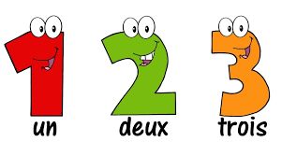

Art

